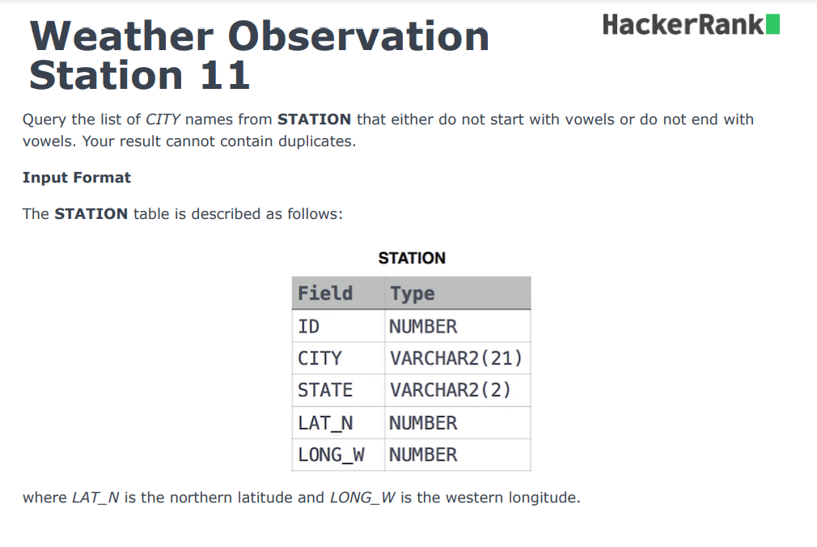

**Solution :-**

select distinct city from station where substr(city,1,1) not in ('A','E','I','O','U') OR lower(substr(city, length(city),1)) not in ('a','e','i','o','u');

**explaination:-**

select is used for retrival the data

distinct is used for the cannot contain duplicate

city is our column name of the(to retival the city name)

station – table name

where clause is used for the appling the condition

for extracting the first character the syntax is substr(string,string_position,length )

so that why our **substr(city,1,1)**

* **CITY: This is the column name from which we are extracting the character. It contains the names of the cities.**
* **SUBSTR: This function is used to extract a substring from a string. Its syntax typically follows this structure:**
  + **SUBSTR(string, start_position, length)**
* **1 (start_position): This specifies the starting position for the extraction. In SQL, string positions are typically 1-based, meaning that the first character of the string is at position 1.**
* **1 (length): This specifies the number of characters to extract. By setting this to 1, we are telling SQL to return only the first character.**

**Example**

**If you have a city name like "Amravati" in the CITY column:**

* **SUBSTR('Amravati', 1, 1) would return 'A'.**

for extracting thr last character (string, length(string) ,1)

* **CITY**: This refers to the column containing city names.
* **SUBSTR**: As previously mentioned, this function extracts a substring from a string. The syntax is:
  + SUBSTR(string, start_position, length)
* **LENGTH(CITY)**: This function returns the total number of characters in the city name. For example, if the city name is "Amravati", LENGTH('Amravati') would return 8.
* **LENGTH(CITY) (start_position)**: By using LENGTH(CITY) as the starting position in SUBSTR, you effectively point to the last character of the string. In a string of length n, the last character is at position n.
* **1 (length)**: This specifies that you want to extract only one character, which is the last character.

**Example**

For a city name like "Amravati":

* LENGTH('Amravati') gives 8.
* SUBSTR('Amravati', 8, 1) would return 'i', which is the last character.